
Astana IT University

Introduction to Threat Hunting

week 9
Atomic Red Team

Students:
Aruzhan Abdulina, Kanasheva Darina

Instructor:

Tendikov Noyan

Submission Date: 29.10.2026
Atomic Red Team is a free, open-source library of small, ready-made tests (“atomics”) published by Red Canary, each mapped to one specific MITRE ATT&CK technique and reproducing exactly one piece of adversary behavior (for example, “create a registry autorun key” or “attempt to dump passwords from memory”). Rather than writing an attack command by hand for every technique, a tester can pull a standardized test from the library and run it with a single command, Invoke-AtomicTest. This makes emulation faster, repeatable, and comparable across different labs or organizations, since the underlying test is identical everywhere. In this lab, Atomic Red Team was used to systematically run several techniques (T1059.001 in this report, T1547.001 and T1003.001 in Week 10) instead of writing each attack from scratch.

The technique chosen here is T1059.001 (Command and Scripting Interpreter: PowerShell), since it directly continues the course theme — it is the technique that fires inside a WinRM session (Weeks 6–8).

Environment Setup and Test Execution
Before running the tests, the execution policy was configured (Set-ExecutionPolicy Bypass -Scope Process -Force) and the C:\AtomicRedTeam folder was added as a Microsoft Defender exclusion (Add-MpPreference -ExclusionPath). The Invoke-AtomicRedTeam module was then installed and a series of tests was launched with Invoke-AtomicTest T1059.001.
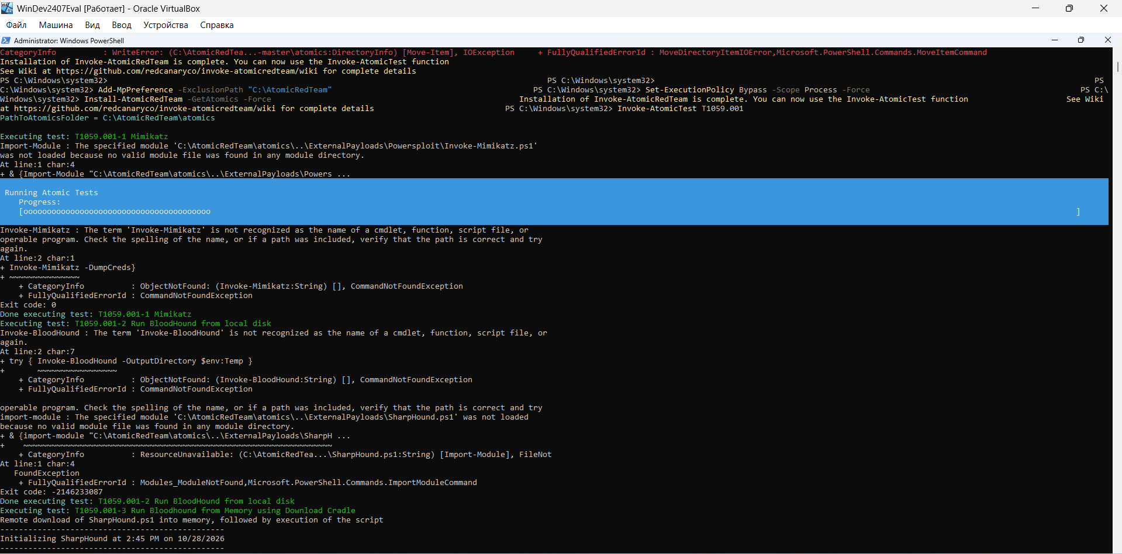
Fig. 1. Installation of Invoke-AtomicRedTeam and execution of the T1059.001 test series. The first sub-tests — T1059.001-1 (Mimikatz) and T1059.001-2/3 (BloodHound) — failed with a CommandNotFoundException: the external payload modules (Invoke-Mimikatz.ps1, SharpHound.ps1) were not found either locally or via the in-memory download cradle. The framework correctly logged the exit code and moved on to the next test without actually executing a credential dump.

Important clarification: despite the sub-test names referencing Mimikatz and BloodHound, they were not actually executed at this step — Atomic Red Team only attempted to run them and correctly reported the missing module. This is expected behavior in an isolated lab environment without pre-staged external payload repositories, not a test failure.

Completion of the Test Series

The framework continued through the remaining T1059.001 sub-tests up to the last ones in the series.
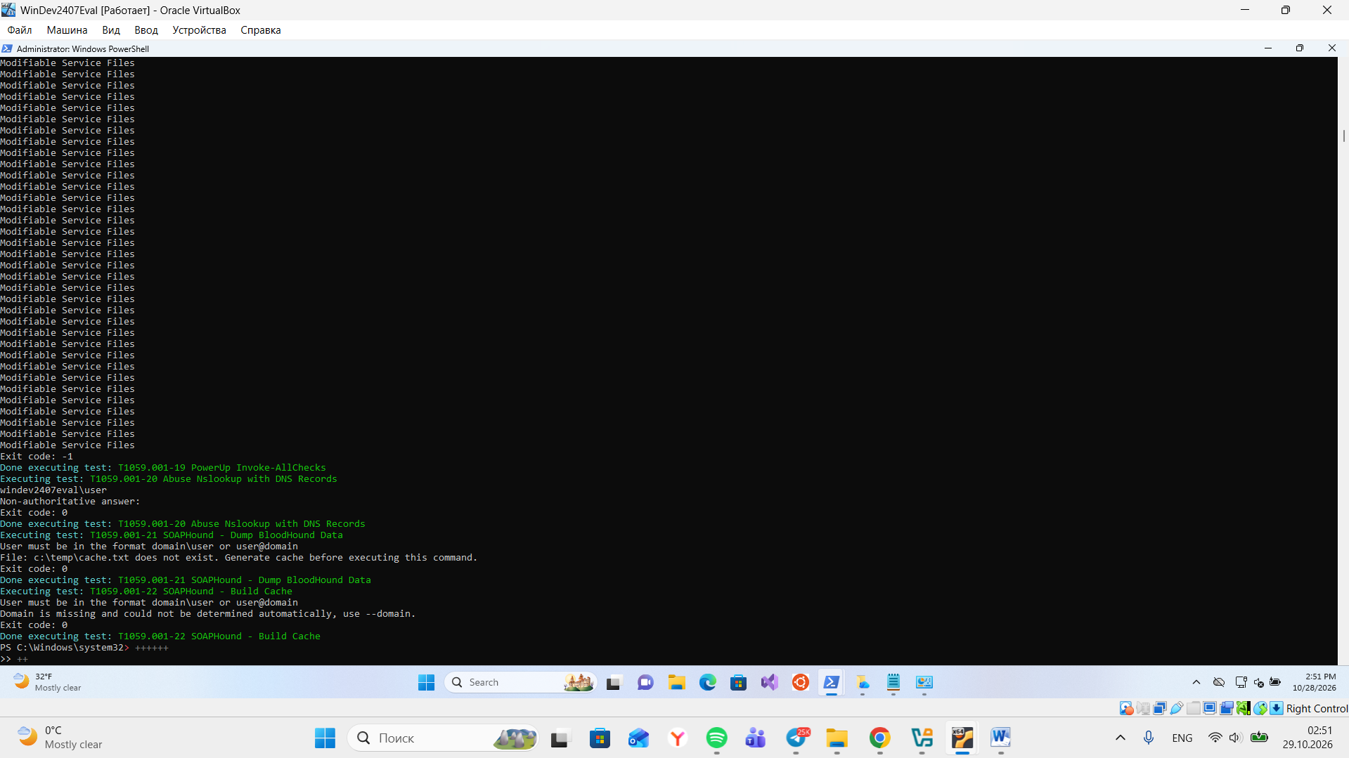
Fig. 2. Final tests in the series: T1059.001-19 (PowerUp Invoke-AllChecks), T1059.001-20 (Abuse Nslookup with DNS Records) — completed successfully, exit code 0), T1059.001-21/22 (SOAPHound — failed due to a missing --domain parameter, expected in an isolated lab network with no Active Directory domain).

Splunk Validation

1 Initial search — unfiltered PowerShell activity
index=main source="WinEventLog:Microsoft-Windows-Sysmon/Operational" EventCode=1 Image="*powershell.exe*" | table _time User Image CommandLine | sort _time
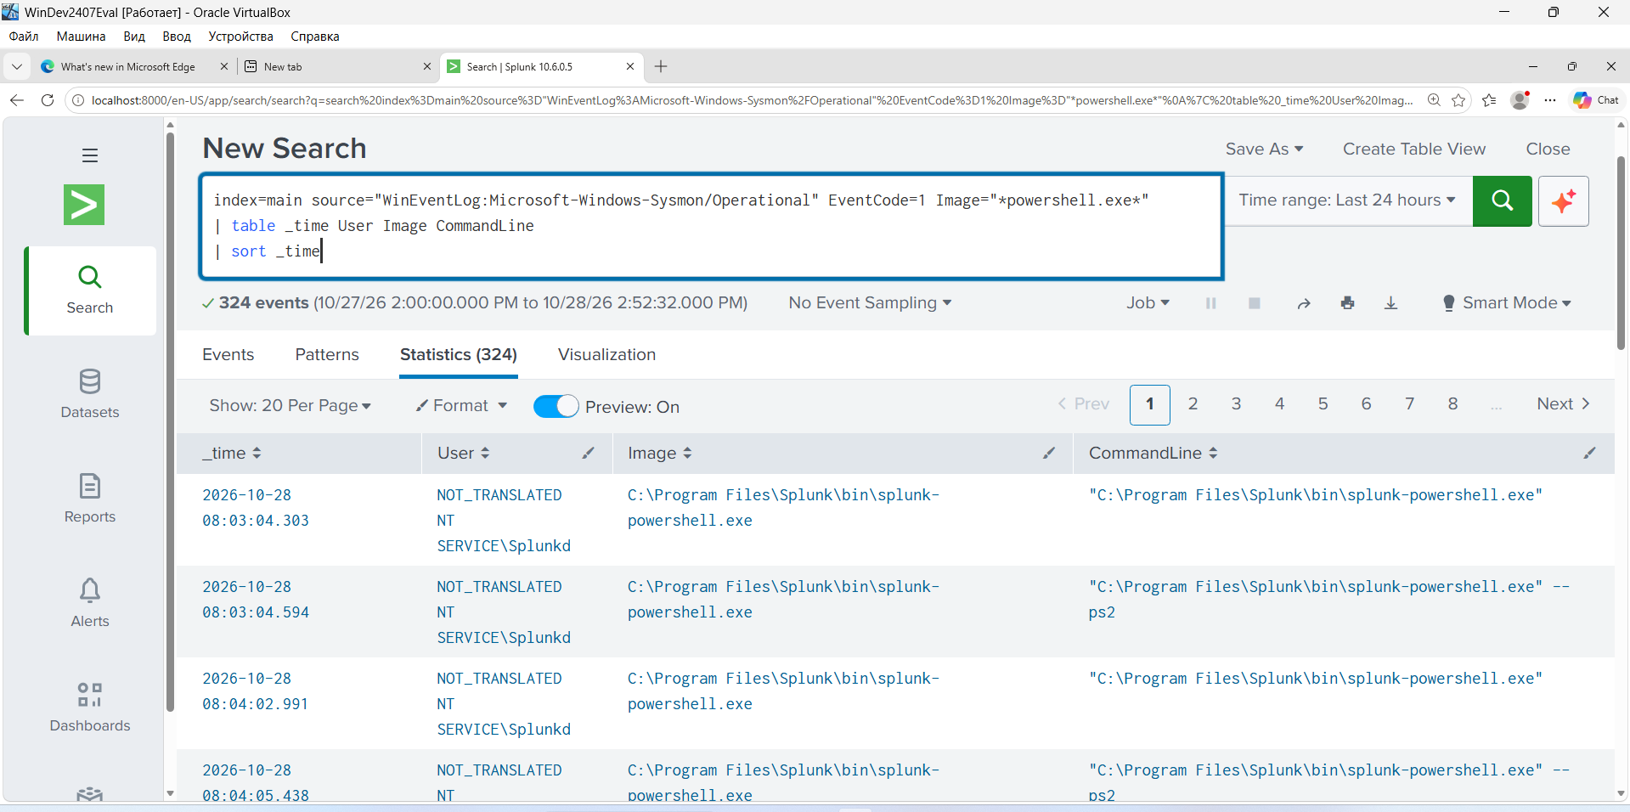
Fig. 3. The query returned 324 events. A large portion of the result set is the background splunk-powershell.exe process spawned by the Splunkd agent itself, not actual atomic-test activity — showing the need for further filtering to isolate the relevant events.

2 Filtered search — excluding Splunk noise
index=main source="WinEventLog:Microsoft-Windows-Sysmon/Operational" EventCode=1 Image="*powershell.exe" NOT Image="*splunk*" | table _time User Image CommandLine | sort _time
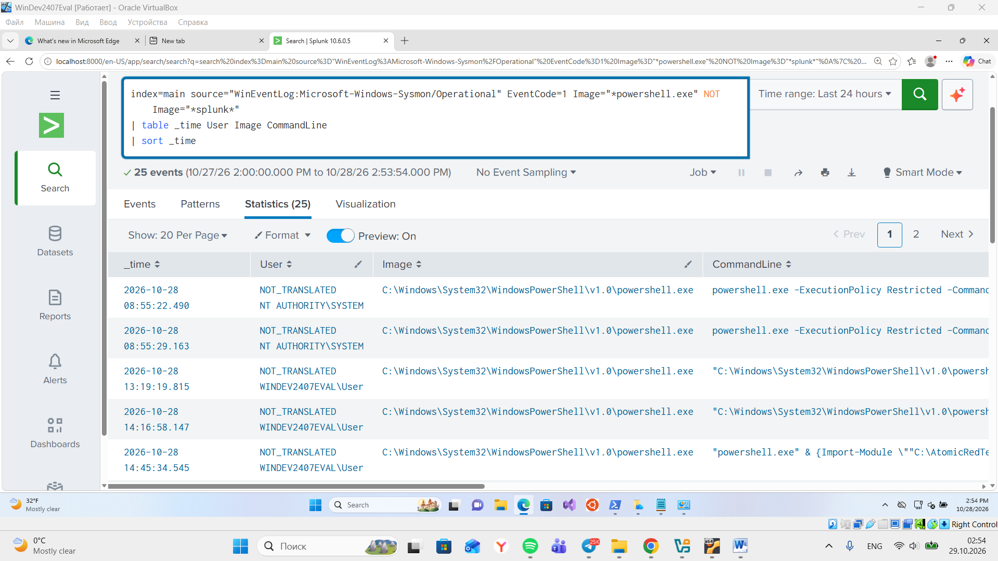
Fig. 4. After excluding Splunk's own background processes, the result set narrowed to 25 events. The CommandLine field shows powershell.exe invoked with -ExecutionPolicy Restricted -Command, running under both NT AUTHORITY\SYSTEM and WINDEV2407EVAL\User, including the Invoke-AtomicRedTeam module import.

Results and Conclusions
- The T1059.001 technique was emulated according to the Atomic Red Team (Red Canary) specification; sub-tests dependent on external payload repositories (Mimikatz, BloodHound, SOAPHound) correctly failed due to missing modules — no actual malicious logic was executed, which is expected and safe for an isolated lab environment.
- Sysmon recorded the creation of every child process (EventCode 1) with the full command-line arguments preserved, confirming that telemetry is configured correctly.
- A raw, unfiltered search for powershell.exe (324 events) contains significant noise from the Splunk agent itself; an effective SPL query must explicitly exclude it (NOT Image="*splunk*"), which narrowed the result set to 25 relevant events.

Conclusion: the practical check confirmed that the log-collection pipeline (Sysmon → Splunk) is configured correctly and that the SIEM can capture execution of T1059.001 atomic tests, provided the correct filtering is applied.

